“Priority” Category Partitioning Testing Tool

OOPT stage 2050 & 2060

Construct & Testing

Project Team

T4

201311265 김상원

201210194 김정환

201311269 김제헌

201311297 이상명

Date

2017-05-24

목차

2050 Construct 3

Activity 2051. Implement Class & Methods Definitions 3

Activity 2052. Implement Windows 19

Activity 2055. Write Unit Test Code 22

2060 Test 22

Activity 2061. Unit Testing 22

Activity 2063. System Testing 22

Activity 2067. Testing Traceability Analysis 22

# 2050 Construct

# Activity 2051. Implement Class & Methods Definitions

|  |  |
| --- | --- |
| **Type** | Class |
| **Name** | MainSystem |
| **Purpose** | 전반적인 프로그램의 수행을 제어하는 클래스 |
| **Overview (Class)** | Specification, FileManager를 가지고 GUI를 호출한다 |
| **Cross Reference** | ALL |
| **Input (Method)** | - |
| **Output (Method)** | - |
| **Abstract Operation(Method)** | - |
| **Exceptional Courses of Events** | N/A |

|  |  |
| --- | --- |
| **Type** | Class |
| **Name** | FileManager |
| **Purpose** | File과 관련된 모든 Event를 담당하는 클래스 |
| **Overview (Class)** | 새로운 파일 생성, 기존 파일 읽기, 파일 저장, 최근파일목록 갱신 등의 기능을 수행한다. |
| **Cross Reference** | R.1.1, R.1.2, R.1.3, R.13 |
| **Input (Method)** | - |
| **Output (Method)** | - |
| **Abstract Operation(Method)** | - |
| **Exceptional Courses of Events** | N/A |

|  |  |
| --- | --- |
| **Type** | Method |
| **Name** | newSpecipication() |
| **Purpose** |  |
| **Overview (Class)** |  |
| **Cross Reference** |  |
| **Input (Method)** | String newFileName |
| **Output (Method)** | Integer |
| **Abstract Operation(Method)** | - |
| **Exceptional Courses of Events** | N/A |

|  |  |
| --- | --- |
| **Type** | Method |
| **Name** | loadSpecification() |
| **Purpose** |  |
| **Overview (Class)** |  |
| **Cross Reference** |  |
| **Input (Method)** | String filePath |
| **Output (Method)** | Integer |
| **Abstract Operation(Method)** | - |
| **Exceptional Courses of Events** | N/A |

|  |  |
| --- | --- |
| **Type** | Method |
| **Name** | saveSpecification() |
| **Purpose** |  |
| **Overview (Class)** |  |
| **Cross Reference** |  |
| **Input (Method)** | void |
| **Output (Method)** | Integer |
| **Abstract Operation(Method)** | - |
| **Exceptional Courses of Events** | N/A |

|  |  |
| --- | --- |
| **Type** | Method |
| **Name** | updateRecentList() |
| **Purpose** |  |
| **Overview (Class)** |  |
| **Cross Reference** |  |
| **Input (Method)** | String filePath |
| **Output (Method)** | Integer |
| **Abstract Operation(Method)** | - |
| **Exceptional Courses of Events** | N/A |

|  |  |
| --- | --- |
| **Type** | Method |
| **Name** | getPath() |
| **Purpose** |  |
| **Overview (Class)** |  |
| **Cross Reference** |  |
| **Input (Method)** | void |
| **Output (Method)** | String |
| **Abstract Operation(Method)** | - |
| **Exceptional Courses of Events** | N/A |

|  |  |
| --- | --- |
| **Type** | Class |
| **Name** | Specification |
| **Purpose** |  |
| **Overview (Class)** |  |
| **Cross Reference** |  |
| **Input (Method)** | - |
| **Output (Method)** | - |
| **Abstract Operation(Method)** | - |
| **Exceptional Courses of Events** | N/A |

|  |  |
| --- | --- |
| **Type** | Method |
| **Name** | generateTestCases() |
| **Purpose** |  |
| **Overview (Class)** |  |
| **Cross Reference** |  |
| **Input (Method)** | void |
| **Output (Method)** | Integer |
| **Abstract Operation(Method)** | - |
| **Exceptional Courses of Events** | N/A |

|  |  |
| --- | --- |
| **Type** | Method |
| **Name** | export2excel() |
| **Purpose** |  |
| **Overview (Class)** |  |
| **Cross Reference** |  |
| **Input (Method)** | void |
| **Output (Method)** | Integer |
| **Abstract Operation(Method)** | - |
| **Exceptional Courses of Events** | N/A |

|  |  |
| --- | --- |
| **Type** | Method |
| **Name** | getCategory() |
| **Purpose** |  |
| **Overview (Class)** |  |
| **Cross Reference** |  |
| **Input (Method)** | categoryIndex |
| **Output (Method)** | Category |
| **Abstract Operation(Method)** | - |
| **Exceptional Courses of Events** | N/A |

|  |  |
| --- | --- |
| **Type** | Method |
| **Name** | setCategory() |
| **Purpose** |  |
| **Overview (Class)** |  |
| **Cross Reference** |  |
| **Input (Method)** | Integer categoryIndex, String categoryName |
| **Output (Method)** | Integer |
| **Abstract Operation(Method)** | - |
| **Exceptional Courses of Events** | N/A |

|  |  |
| --- | --- |
| **Type** | Method |
| **Name** | addCategory() |
| **Purpose** |  |
| **Overview (Class)** |  |
| **Cross Reference** |  |
| **Input (Method)** | String categoryName |
| **Output (Method)** | Integer |
| **Abstract Operation(Method)** | - |
| **Exceptional Courses of Events** | N/A |

|  |  |
| --- | --- |
| **Type** | Method |
| **Name** | delCategory() |
| **Purpose** |  |
| **Overview (Class)** |  |
| **Cross Reference** |  |
| **Input (Method)** | Integer categoryIndex |
| **Output (Method)** | Integer |
| **Abstract Operation(Method)** | - |
| **Exceptional Courses of Events** | N/A |

|  |  |
| --- | --- |
| **Type** | Method |
| **Name** | void updateData() |
| **Purpose** |  |
| **Overview (Class)** |  |
| **Cross Reference** |  |
| **Input (Method)** | Void |
| **Output (Method)** | void |
| **Abstract Operation(Method)** | - |
| **Exceptional Courses of Events** | N/A |

|  |  |
| --- | --- |
| **Type** | Class |
| **Name** | Category |
| **Purpose** |  |
| **Overview (Class)** |  |
| **Cross Reference** |  |
| **Input (Method)** | - |
| **Output (Method)** | - |
| **Abstract Operation(Method)** | - |
| **Exceptional Courses of Events** | N/A |

|  |  |
| --- | --- |
| **Type** | Method |
| **Name** | setCategoryName() |
| **Purpose** |  |
| **Overview (Class)** |  |
| **Cross Reference** |  |
| **Input (Method)** | String categoryName |
| **Output (Method)** | Integer |
| **Abstract Operation(Method)** | - |
| **Exceptional Courses of Events** | N/A |

|  |  |
| --- | --- |
| **Type** | Method |
| **Name** | getCategoryName() |
| **Purpose** |  |
| **Overview (Class)** |  |
| **Cross Reference** |  |
| **Input (Method)** | void |
| **Output (Method)** | String |
| **Abstract Operation(Method)** | - |
| **Exceptional Courses of Events** | N/A |

|  |  |
| --- | --- |
| **Type** | Method |
| **Name** | getRepresentativeValue() |
| **Purpose** |  |
| **Overview (Class)** |  |
| **Cross Reference** |  |
| **Input (Method)** | Integer representativeIndex |
| **Output (Method)** | RepresentativeValue |
| **Abstract Operation(Method)** | - |
| **Exceptional Courses of Events** | N/A |

|  |  |
| --- | --- |
| **Type** | Method |
| **Name** | setRepresentativeValue() |
| **Purpose** |  |
| **Overview (Class)** |  |
| **Cross Reference** |  |
| **Input (Method)** | Integer representativeValueIndex, String representativeValueName |
| **Output (Method)** | Integer |
| **Abstract Operation(Method)** | - |
| **Exceptional Courses of Events** | N/A |

|  |  |
| --- | --- |
| **Type** | Method |
| **Name** | addRepresentativeValue() |
| **Purpose** |  |
| **Overview (Class)** |  |
| **Cross Reference** |  |
| **Input (Method)** | String representativeValueName |
| **Output (Method)** | Integer |
| **Abstract Operation(Method)** | - |
| **Exceptional Courses of Events** | N/A |

|  |  |
| --- | --- |
| **Type** | Method |
| **Name** | delRepresentativeValue() |
| **Purpose** |  |
| **Overview (Class)** |  |
| **Cross Reference** |  |
| **Input (Method)** | Integer representativeValueIndex |
| **Output (Method)** | Integer |
| **Abstract Operation(Method)** | - |
| **Exceptional Courses of Events** | N/A |

|  |  |
| --- | --- |
| **Type** | Class |
| **Name** | RepresentativeValue |
| **Purpose** |  |
| **Overview (Class)** |  |
| **Cross Reference** |  |
| **Input (Method)** | - |
| **Output (Method)** | - |
| **Abstract Operation(Method)** | - |
| **Exceptional Courses of Events** | N/A |

|  |  |
| --- | --- |
| **Type** | Method |
| **Name** | getNumberOfPropertyConstraints() |
| **Purpose** |  |
| **Overview (Class)** |  |
| **Cross Reference** |  |
| **Input (Method)** | Void |
| **Output (Method)** | Integer |
| **Abstract Operation(Method)** | - |
| **Exceptional Courses of Events** | N/A |

|  |  |
| --- | --- |
| **Type** | Method |
| **Name** | getNumberOfIfPropertyConstraints() |
| **Purpose** |  |
| **Overview (Class)** |  |
| **Cross Reference** |  |
| **Input (Method)** | Void |
| **Output (Method)** | Integer |
| **Abstract Operation(Method)** | - |
| **Exceptional Courses of Events** | N/A |

|  |  |
| --- | --- |
| **Type** | Method |
| **Name** | setRepresentativeValueName() |
| **Purpose** |  |
| **Overview (Class)** |  |
| **Cross Reference** |  |
| **Input (Method)** | String representativeValueName |
| **Output (Method)** | Integer |
| **Abstract Operation(Method)** | - |
| **Exceptional Courses of Events** | N/A |

|  |  |
| --- | --- |
| **Type** | Method |
| **Name** | getRepresentativeValueName() |
| **Purpose** |  |
| **Overview (Class)** |  |
| **Cross Reference** |  |
| **Input (Method)** | Void |
| **Output (Method)** | String |
| **Abstract Operation(Method)** | - |
| **Exceptional Courses of Events** | N/A |

|  |  |
| --- | --- |
| **Type** | Method |
| **Name** | setProperty() |
| **Purpose** |  |
| **Overview (Class)** |  |
| **Cross Reference** |  |
| **Input (Method)** | Integer propertyIndex, String propertyName |
| **Output (Method)** | Integer |
| **Abstract Operation(Method)** | - |
| **Exceptional Courses of Events** | N/A |

|  |  |
| --- | --- |
| **Type** | Method |
| **Name** | addProperty() |
| **Purpose** |  |
| **Overview (Class)** |  |
| **Cross Reference** |  |
| **Input (Method)** | String propertyName |
| **Output (Method)** | Integer |
| **Abstract Operation(Method)** | - |
| **Exceptional Courses of Events** | N/A |

|  |  |
| --- | --- |
| **Type** | Method |
| **Name** | delProperty() |
| **Purpose** |  |
| **Overview (Class)** |  |
| **Cross Reference** |  |
| **Input (Method)** | Integer propertyIndex |
| **Output (Method)** | Integer |
| **Abstract Operation(Method)** | - |
| **Exceptional Courses of Events** | N/A |

|  |  |
| --- | --- |
| **Type** | Method |
| **Name** | setIfProperty() |
| **Purpose** |  |
| **Overview (Class)** |  |
| **Cross Reference** |  |
| **Input (Method)** | Integer ifPropertyIndex, String ifPropertyName |
| **Output (Method)** | Integer |
| **Abstract Operation(Method)** | - |
| **Exceptional Courses of Events** | N/A |

|  |  |
| --- | --- |
| **Type** | Method |
| **Name** | addIfProperty() |
| **Purpose** |  |
| **Overview (Class)** |  |
| **Cross Reference** |  |
| **Input (Method)** | String ifPropertyName |
| **Output (Method)** | Integer |
| **Abstract Operation(Method)** | - |
| **Exceptional Courses of Events** | N/A |

|  |  |
| --- | --- |
| **Type** | Method |
| **Name** | deIfProperty() |
| **Purpose** |  |
| **Overview (Class)** |  |
| **Cross Reference** |  |
| **Input (Method)** | Integer ifPropertyIndex |
| **Output (Method)** | Integer |
| **Abstract Operation(Method)** | - |
| **Exceptional Courses of Events** | N/A |

|  |  |
| --- | --- |
| **Type** | Method |
| **Name** | setSingleError() |
| **Purpose** |  |
| **Overview (Class)** |  |
| **Cross Reference** |  |
| **Input (Method)** | Integer singleError |
| **Output (Method)** | Integer |
| **Abstract Operation(Method)** | - |
| **Exceptional Courses of Events** | N/A |

|  |  |
| --- | --- |
| **Type** | Method |
| **Name** | setPriorityRank() |
| **Purpose** |  |
| **Overview (Class)** |  |
| **Cross Reference** |  |
| **Input (Method)** | Integer priorityRank |
| **Output (Method)** | Integer |
| **Abstract Operation(Method)** | - |
| **Exceptional Courses of Events** | N/A |

|  |  |
| --- | --- |
| **Type** | Method |
| **Name** | getProperty() |
| **Purpose** |  |
| **Overview (Class)** |  |
| **Cross Reference** |  |
| **Input (Method)** | Integer propertyIndex |
| **Output (Method)** | Property |
| **Abstract Operation(Method)** | - |
| **Exceptional Courses of Events** | N/A |

|  |  |
| --- | --- |
| **Type** | Method |
| **Name** | getIfProperty() |
| **Purpose** |  |
| **Overview (Class)** |  |
| **Cross Reference** |  |
| **Input (Method)** | Integer ifPropertyIndex |
| **Output (Method)** | Property |
| **Abstract Operation(Method)** | - |
| **Exceptional Courses of Events** | N/A |

|  |  |
| --- | --- |
| **Type** | Method |
| **Name** | getSingleError() |
| **Purpose** |  |
| **Overview (Class)** |  |
| **Cross Reference** |  |
| **Input (Method)** | Void |
| **Output (Method)** | Integer |
| **Abstract Operation(Method)** | - |
| **Exceptional Courses of Events** | N/A |

|  |  |
| --- | --- |
| **Type** | Method |
| **Name** | getPriorityRank() |
| **Purpose** |  |
| **Overview (Class)** |  |
| **Cross Reference** |  |
| **Input (Method)** | Void |
| **Output (Method)** | Integer |
| **Abstract Operation(Method)** | - |
| **Exceptional Courses of Events** | N/A |

|  |  |
| --- | --- |
| **Type** | Class |
| **Name** | Property |
| **Purpose** |  |
| **Overview (Class)** |  |
| **Cross Reference** |  |
| **Input (Method)** | - |
| **Output (Method)** | - |
| **Abstract Operation(Method)** | - |
| **Exceptional Courses of Events** | N/A |

|  |  |
| --- | --- |
| **Type** | Method |
| **Name** | getName() |
| **Purpose** |  |
| **Overview (Class)** |  |
| **Cross Reference** |  |
| **Input (Method)** | void |
| **Output (Method)** | String |
| **Abstract Operation(Method)** | - |
| **Exceptional Courses of Events** | N/A |

|  |  |
| --- | --- |
| **Type** | Method |
| **Name** | setName() |
| **Purpose** |  |
| **Overview (Class)** |  |
| **Cross Reference** |  |
| **Input (Method)** | String name |
| **Output (Method)** | Integer |
| **Abstract Operation(Method)** | - |
| **Exceptional Courses of Events** | N/A |

|  |  |
| --- | --- |
| **Type** | Method |
| **Name** | addName() |
| **Purpose** |  |
| **Overview (Class)** |  |
| **Cross Reference** |  |
| **Input (Method)** | String valueName |
| **Output (Method)** | void |
| **Abstract Operation(Method)** | - |
| **Exceptional Courses of Events** | N/A |

|  |  |
| --- | --- |
| **Type** | Method |
| **Name** | isOnly() |
| **Purpose** |  |
| **Overview (Class)** |  |
| **Cross Reference** |  |
| **Input (Method)** | void |
| **Output (Method)** | Boolean |
| **Abstract Operation(Method)** | - |
| **Exceptional Courses of Events** | N/A |

|  |  |
| --- | --- |
| **Type** | Method |
| **Name** | delName() |
| **Purpose** |  |
| **Overview (Class)** |  |
| **Cross Reference** |  |
| **Input (Method)** | String valueName |
| **Output (Method)** | void |
| **Abstract Operation(Method)** | - |
| **Exceptional Courses of Events** | N/A |

# Activity 2052. Implement Windows

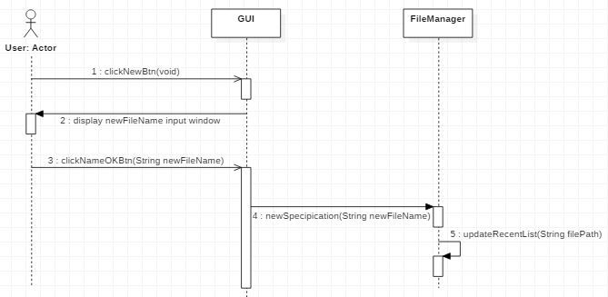

|  |  |
| --- | --- |
| **Name** | newSpecification |
| **Responsibilities** | GUI에서 ‘새로 만들기’버튼을 클릭하고, 새로 만들 Specification파일 이름을 입력 받는다. |
| **Type** | GUI |
| **Cross Reference** | R1.1 |
| **Notes** | 저장할 파일 이름을 입력 받는 화면이 출력된다. 추후 사용자로부터 입력 받은 이름으로 새로운 specification파일을 생성한다. 최근 파일 항목에 반영한다. |
| **Pre-Conditions** | N/A |
| **Post-Conditions** | Specification파일을 작성하기 위한 화면으로 넘어간다. |

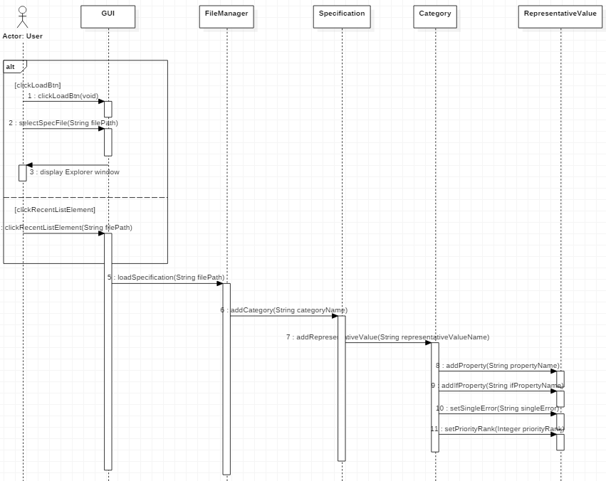

|  |  |
| --- | --- |
| **Name** | loadSpecification |
| **Responsibilities** | GUI에서 ‘불러오기’버튼을 클릭하거나, 최근 파일 목록 중 하나를 클릭한다. |
| **Type** | GUI |
| **Cross Reference** | R1.2 |
| **Notes** | 기존에 작성한 Specification파일을 불러온다. 최근 파일 항목에 반영한다. |
| **Pre-Conditions** | 불러올 Specification파일 또는 recent file list에 specification  파일이 있어야 한다. |
| **Post-Conditions** | Specification파일을 작성하기 위한 화면으로 넘어간다. |

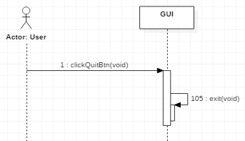

|  |  |
| --- | --- |
| **Name** | shutdownProgram |
| **Responsibilities** | GUI에서 ‘종료하기’ 버튼을 클릭한다. |
| **Type** | GUI |
| **Cross Reference** | R1.3 |
| **Notes** | 프로그램을 종료한다. |
| **Pre-Conditions** | N/A |
| **Post-Conditions** | N/A |

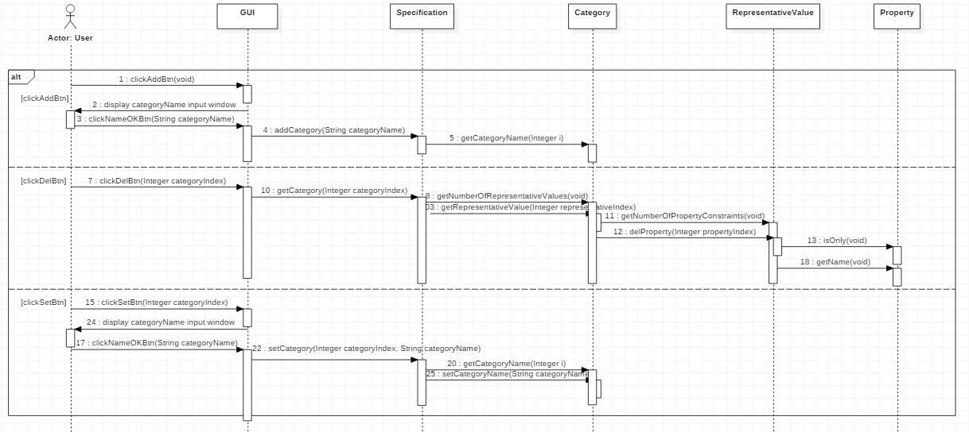

|  |  |
| --- | --- |
| **Name** | setCategory |
| **Responsibilities** | GUI에서 category에 대해 ‘추가’, 또는 ‘수정’, ‘삭제’버튼을 클릭한다. |
| **Type** | GUI |
| **Cross Reference** | R2.1 |
| **Notes** | 새로운 category를 추가 또는 이미 작성된 category를 수정하거나 지운다. |
| **Pre-Conditions** | ‘수정’, ‘삭제’버튼이 작동하기 위해서는 이미 추가된 category가 있어야 한다. |
| **Post-Conditions** | 클릭한 버튼의 결과가 Specification 및 화면에 반영된다. |

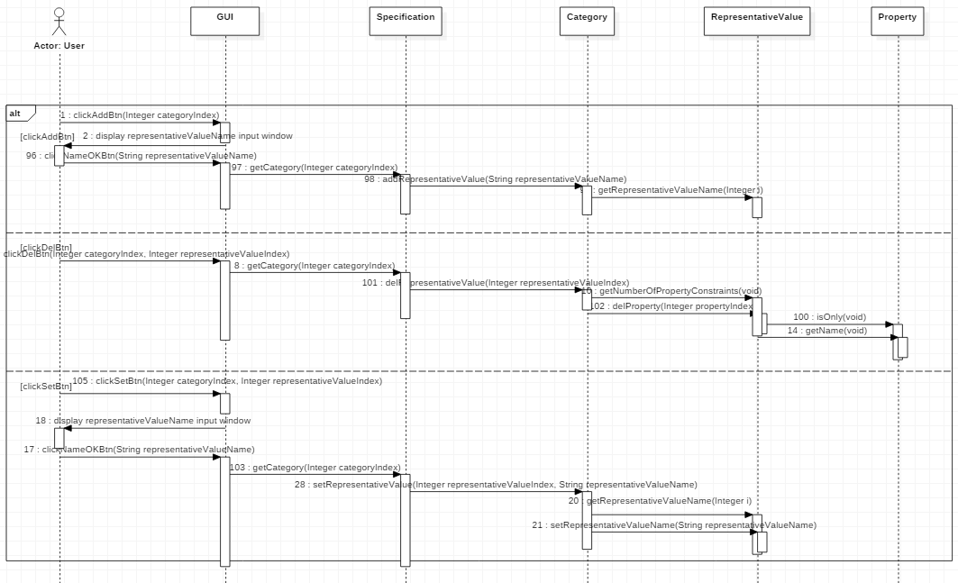

|  |  |
| --- | --- |
| **Name** | setRepresentativeValue |
| **Responsibilities** | GUI에서 representativeValue에 대해 ‘추가’, 또는 ‘수정’, ‘삭제’버튼을 클릭한다. |
| **Type** | GUI |
| **Cross Reference** | R2.2 |
| **Notes** | 새로운 representativeValue를 추가 또는 이미 작성된 representativeValue를 수정하거나 지운다. |
| **Pre-Conditions** | ‘수정’, ‘삭제’버튼이 작동하기 위해서는 이미 추가된 representativeValue가 있어야 한다. |
| **Post-Conditions** | 클릭한 버튼의 결과가 Specification 및 화면에 반영된다. |

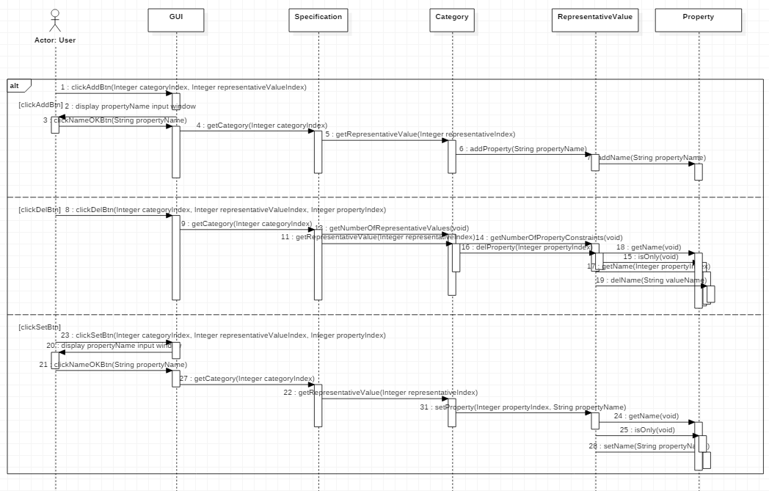

|  |  |
| --- | --- |
| **Name** | setProperty |
| **Responsibilities** | GUI에서 property에 대해 ‘추가’, 또는 ‘수정’, ‘삭제’버튼을 클릭한다. |
| **Type** | GUI |
| **Cross Reference** | R2.3 |
| **Notes** | 새로운 property를 추가 또는 이미 작성된 property를 수정하거나 지운다. |
| **Pre-Conditions** | ‘수정’, ‘삭제’버튼이 작동하기 위해서는 이미 추가된 property가 있어야 한다. |
| **Post-Conditions** | 클릭한 버튼의 결과가 Specification 및 화면에 반영된다. |

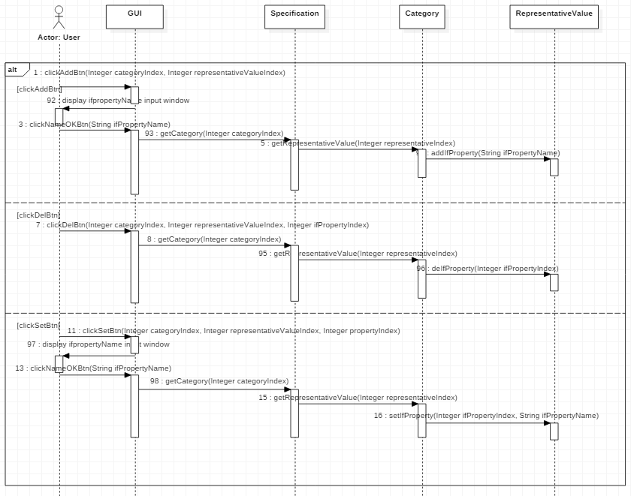

|  |  |
| --- | --- |
| **Name** | setIfProperty |
| **Responsibilities** | GUI에서 if-property에 대해 ‘추가’, 또는 ‘수정’, ‘삭제’버튼을 클릭한다. |
| **Type** | GUI |
| **Cross Reference** | R2.4 |
| **Notes** | 새로운 if-property를 추가 또는 이미 작성된 if-property를 수정하거나 지운다. |
| **Pre-Conditions** | ‘수정’, ‘삭제’버튼이 작동하기 위해서는 이미 추가된 if-property가 있어야 한다. |
| **Post-Conditions** | 클릭한 버튼의 결과가 Specification 및 화면에 반영된다. |

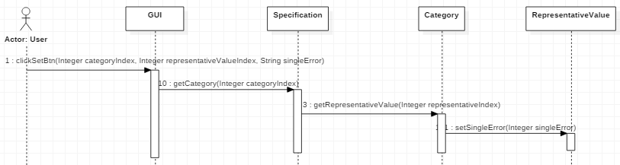

|  |  |
| --- | --- |
| **Name** | setSingleError |
| **Responsibilities** | GUI에서 single 또는 error constraint에 대해서 클릭한다. |
| **Type** | GUI |
| **Cross Reference** | R2.5 |
| **Notes** | 선택 받은 single 또는 error constraint 중 하나를 부여한다. [선택을 안 할 수도 있음] |
| **Pre-Conditions** | N/A |
| **Post-Conditions** | 클릭한 버튼의 결과가 Specification 및 화면에 반영된다. |

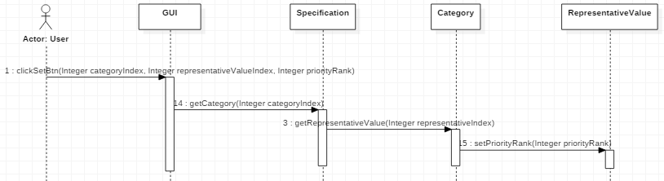

|  |  |
| --- | --- |
| **Name** | setPriorityRank |
| **Responsibilities** | GUI에서 priority에 대해 총 1~5점 중 하나를 클릭한다. |
| **Type** | GUI |
| **Cross Reference** | R2.6 |
| **Notes** | priority(중요도)를 선택 받은 1~5점 중 하나로 부여한다. |
| **Pre-Conditions** | N/A |
| **Post-Conditions** | 클릭한 버튼의 결과가 Specification 및 화면에 반영된다. |

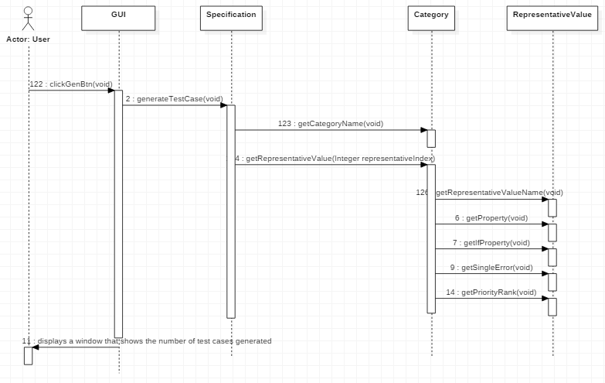

|  |  |
| --- | --- |
| **Name** | generateTestCases |
| **Responsibilities** | GUI에서 ‘Test case 생성 후 엑셀로 저장하기’ 버튼을 클릭한다. |
| **Type** | GUI |
| **Cross Reference** | R3 |
| **Notes** | 입력된 Specification을 통해 test case를 만들고 그 총 개수를 화면을 통해 사용자에게 알려준다. |
| **Pre-Conditions** | 입력된 Specification이 test case를 만들기 위한 충분한 값이 입력되어야 한다. |
| **Post-Conditions** | test case를 만들고 그 총 개수를 화면을 통해 사용자에게 알려준다. |

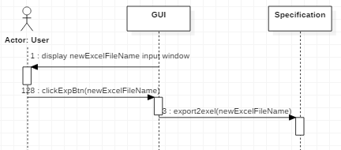

|  |  |
| --- | --- |
| **Name** | export2excel |
| **Responsibilities** | GUI에서 생성할 Test case 엑셀파일의 이름을 입력 받는다. |
| **Type** | GUI |
| **Cross Reference** | R4 |
| **Notes** | Test case generate이 끝난 후, 생성할 엑셀파일의 이름을 받는다. 이후 생성된 test cases를 Priority순으로 정렬한 후, 입력 받은 이름의 엑셀 파일에 저장한다. |
| **Pre-Conditions** | 입력된 Specification이 test case를 만들기 위한 충분한 값이 입력되어서, Generate test cases가 실행되어야 한다. |
| **Post-Conditions** | 생성된 Test case를 입력 받은 이름의 엑셀 파일에 저장한다. |

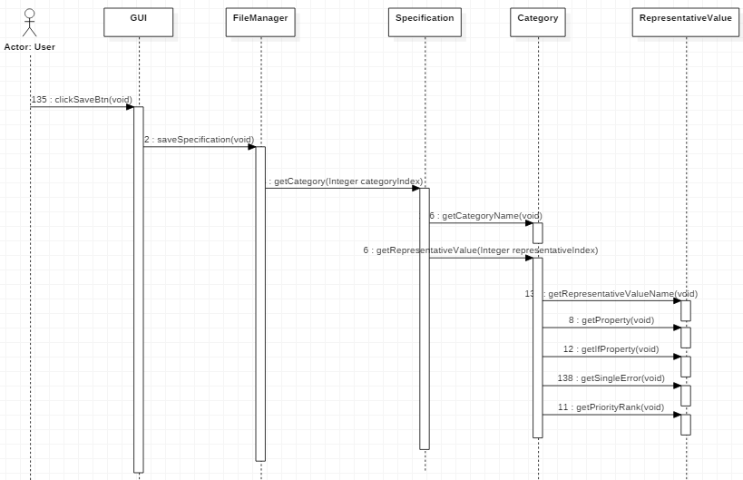

|  |  |
| --- | --- |
| **Name** | saveSpecification |
| **Responsibilities** | GUI에서 ‘저장하기’ 버튼을 클릭한다. |
| **Type** | GUI |
| **Cross Reference** | R5 |
| **Notes** | specification입력 중간저장 버튼을 누르면, 현재까지의 작업 상태를 저장한다. |
| **Pre-Conditions** | N/A |
| **Post-Conditions** | 현재까지의 작업 상태를 specification 파일로 저장한다. |

# Activity 2055. Write Unit Test Code

# 2060 Test

# Activity 2061. Unit Testing

# Activity 2063. System Testing

# Activity 2067. Testing Traceability Analysis